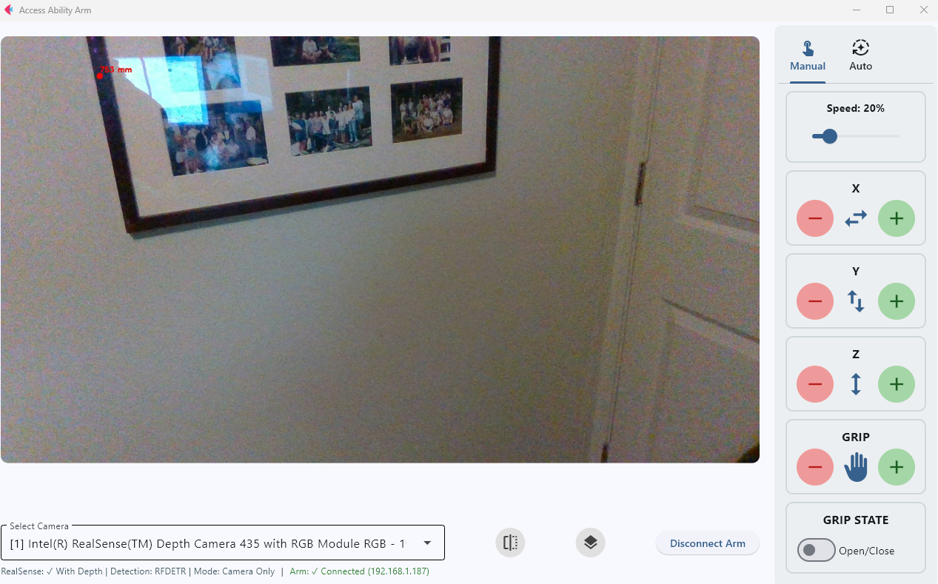
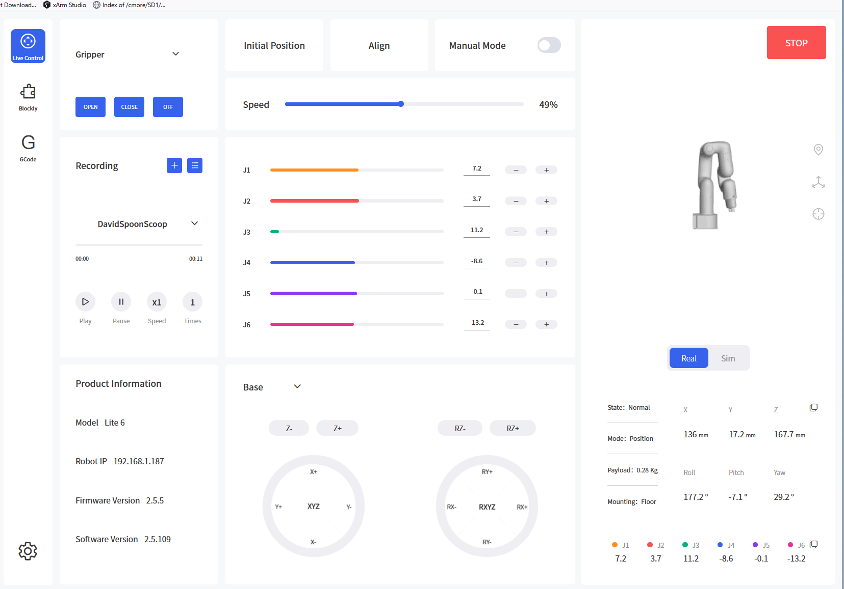
- Add drop down menu that allows choices of operating modes…
  - Base Coordinates (X away from base, Y to left of base, Z up)
    - X, Y, Z, RX, RY, RZ
  - Tool Coordinates (X “up”, Y “right”, Z “into part”, all relative to rotational position of gripper. Twist gripper 90 degrees and x and y basically switch relative to the real world)
    - X, Y, Z, RX, RY, RZ
  - Screen Coordinates (similar to “b”, but maybe tipped relative to the tool?)
  - Joint Controls (Just like the Ufactory interface…and maybe just do the ufactory interface?)
  - UFactory Interface
  - Utilities (also redundant to the ufactory interface except for calibrating to cmaera or maybe gripper functions)
- Add the functionalities of those items.
- Allow held click movement of the robot instead of just clicks (see older joystick control for possible how)
- Data transform of camera space to gripper or base space.
- Calibrate utility? Using grid paper?
- Calibrate gripper? No gripper…so need to think how. Maybe it can be in view? Or maybe it holds something special then moves it in the view of the camera?

